PROJECT REPORT: APPROACH 3 - Transfer Learning with YAMNet for Audio Classification

1. EXECUTIVE SUMMARY
This report details "Approach 3," a successful method for creating a real-time, on-device audio classification model. The goal was to train a model to classify 6 custom audio types.
This approach used transfer learning, leveraging Google's pre-trained YAMNet model as a feature extractor. A new, custom classifier was trained on the embeddings from YAMNet.
This method proved highly effective, resulting in two models:
- A per-frame classifier with 84% accuracy.
- A final, end-to-end "serving model" (TFLite, 14.85 MB) that aggregates predictions and achieves a robust 92% per-file accuracy.
The final model is lightweight, accurate, and ready for deployment on mobile devices.

2. ARCHITECTURE AND METHODOLOGY
A. Overview
Instead of training a new model from scratch (which requires massive datasets), this approach uses transfer learning. We "borrow" the hearing ability of YAMNet, which is already an expert at recognizing general sounds. We then train a new, small classifier to map YAMNet's understanding to our specific classes.
B. Architectural Diagram
The architecture is split into three distinct pipelines: Training, Inference, and Deployment.
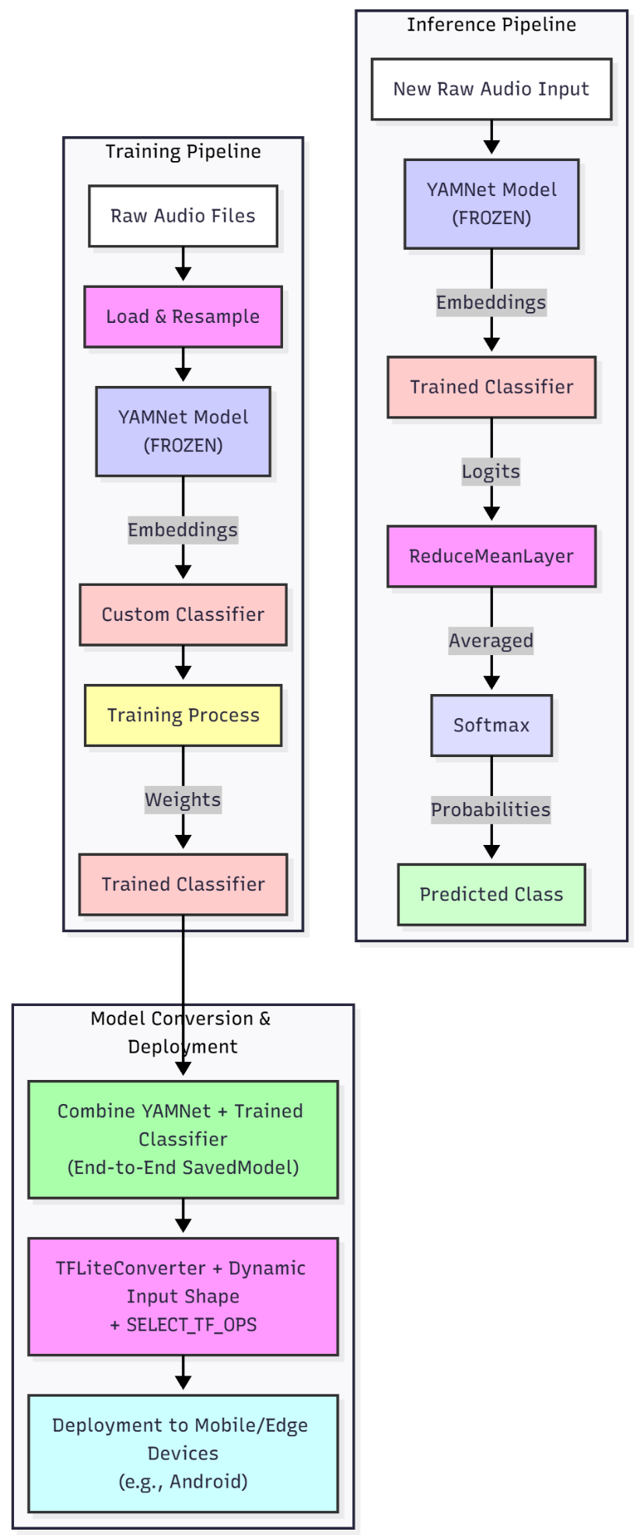
- Training Pipeline: This is the offline process used to build the model. It feeds our entire dataset into a frozen YAMNet, extracts the features (embeddings), and uses them to train our new, custom classifier.
- Inference Pipeline: This is the "live" process used by the final app. It takes a single audio file, feeds it through YAMNet, gets the frame-by-frame predictions from our classifier, and then uses a ReduceMeanLayer to average all predictions into one final, confident answer.
- Deployment Pipeline: This is the one-time step that combines the YAMNet model and our trained classifier into a single, end-to-end "serving model," which is then converted into the final TFLite file.

3. DATA ANALYSIS AND PREPARATION
A. Dataset
The dataset consisted of 1,043 audio files distributed across 6 classes:
- Alarm_Clock
- Background
- Car_Horn
- Glass_Breaking
- Gunshot
- Siren
B. Visualization: Data Distribution
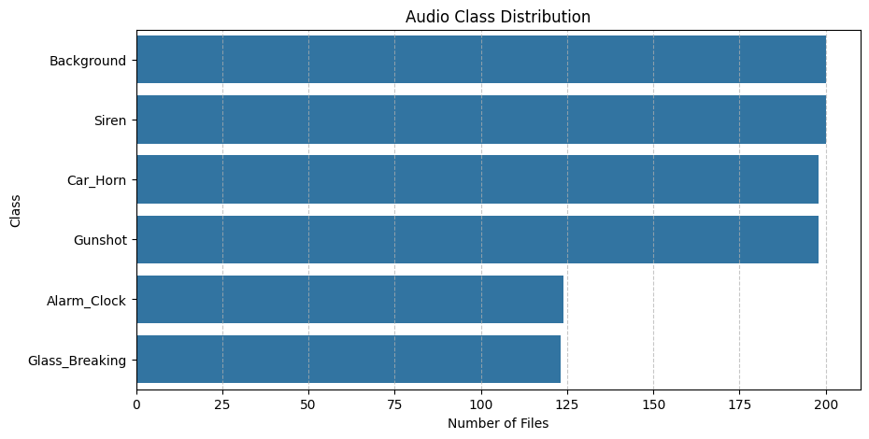
C. Analysis of Data
As the bar chart shows, the dataset was moderately imbalanced.
- Majority Classes: Background, Siren, Car_Horn, and Gunshot all had approximately 200 files each.
- Minority Classes: Alarm_Clock (124 files) and Glass_Breaking (123 files) had significantly less data, about 40% less than the majority classes.
This imbalance was a key factor to watch during training, as it could lead to the model being biased against these minority classes.

4. MODEL TRAINING AND ANALYSIS (MODEL 1: KERAS CLASSIFIER)
A. Process
The 1,043 audio files were processed by YAMNet and converted into 4,745 individual embedding vectors (frames). A new, simple neural network was trained on these 4,745 frames.
B. Result 1: 84% Per-Frame Accuracy
This initial model, which predicts the class for every single 0.48s audio frame, achieved a validation accuracy of 84%.
C. Visualization: Training & Validation History (Loss/Accuracy)
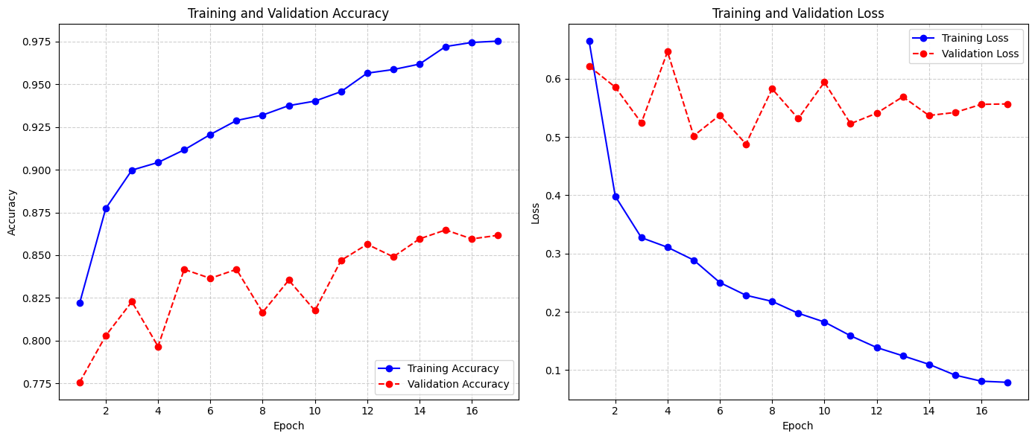
D. Analysis of Training History
The training plot provides two critical insights:
- Overfitting: The "Training Accuracy" (blue line) quickly rose to 97%, while the "Validation Accuracy" (red line) plateaued at 84%. This 13% gap is a clear sign of overfitting, where the model was memorizing the training data instead of generalizing.
- Callbacks: The EarlyStopping callback worked correctly, stopping the training at Epoch 17 when it detected the validation loss was no longer improving. This prevented extreme overfitting and saved the model's best-performing weights (from around Epoch 14).
E. Visualization: Keras Confusion Matrix (Per-Frame)
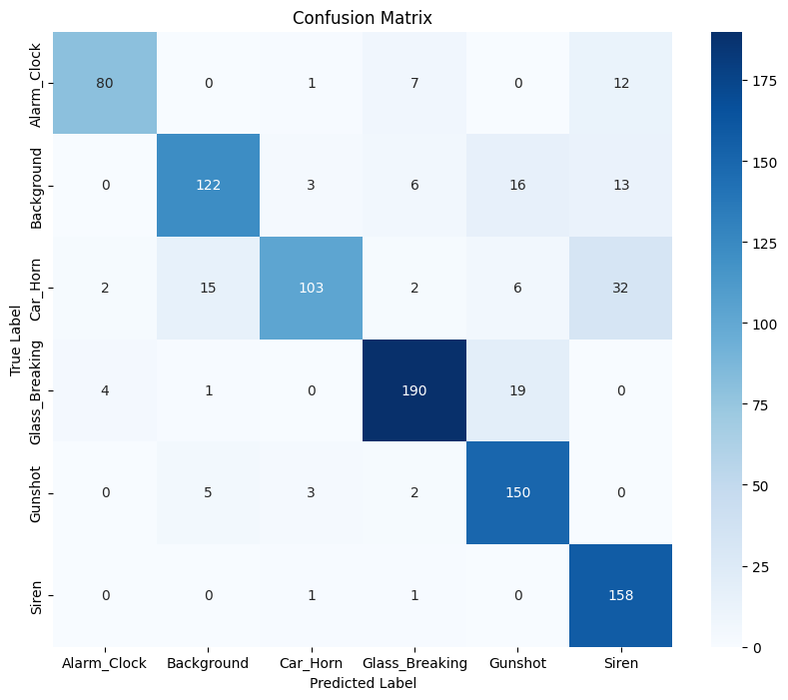
F. Analysis of Per-Frame Confusions
This matrix is the most important tool for understanding the model's flaws. It shows the errors on a frame-by-frame basis.
- Key Problem 1 (Car_Horn): The Car_Horn class had a very low recall of 64%. The matrix shows that out of 160 true Car_Horn frames, 32 were misclassified as Siren and 15 were misclassified as Background. This is a logical error, as all three sounds can be continuous and in a similar frequency range.
- Key Problem 2 (Siren): The Siren class had a low precision of 73%. This means that while it found most sirens, it also falsely classified many other sounds as Siren. The matrix shows that 12 Alarm_Clock frames and 32 Car_Horn frames were all misidentified as Siren.
This analysis proves that at a "per-frame" level, these similar-sounding classes are very difficult for the model to distinguish.

5. TFLITE CONVERSION AND FINAL VALIDATION (MODEL 2: SERVING MODEL)
A. Process
This step was designed to fix the "per-frame" problem. The trained classifier was combined with YAMNet and a ReduceMeanLayer into a single end-to-end model. This layer's job is to average all the frame-by-frame predictions for a single audio file.
This final model was then converted to TFLite, resulting in a 14.85 MB file.
B. Result 2: 92% Per-File Accuracy
The TFLite model was tested on a "per-file" basis, which mimics how an app would use it. By averaging the predictions, the model's performance jumped from 84% to 92% accuracy.
This proves that the TFLite conversion was successful and resulted in no loss of accuracy.
C. The "Magic" of Averaging
The 8% accuracy increase is due to the ReduceMeanLayer. For example, a 3-second Car_Horn clip might have 5 frames. The per-frame predictions might be:
[Car_Horn, Car_Horn, Siren, Car_Horn, Background]
The per-frame model (Model 1) would see 2 errors. But the final "serving model" (Model 2) averages these "votes." The majority vote is Car_Horn, so the model makes one, correct, high-confidence prediction. This averaging successfully filters out the frame-level noise and confusion.
D. Visualization: TFLite Confusion Matrix (Per-File)
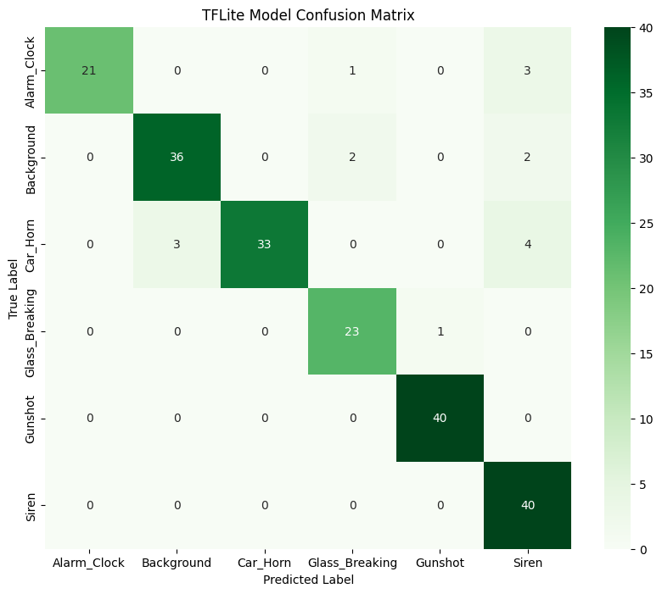
E. Analysis of Final TFLite Confusions
This matrix shows the performance of the final 92% accurate model.
- Car_Horn Fixed: The Car_Horn recall jumped from 64% to 82%. The averaging logic fixed most of the confusion with Siren and Background.
- Remaining Errors: The errors that remain are the same logical ones we saw before, but far less frequent. For example, the matrix shows 3 Alarm_Clock files were still misclassified as Siren. This is the model's primary remaining weakness.

7. CONCLUSION AND FUTURE WORK
Approach 3 was highly successful. By combining a pre-trained YAMNet model with a custom classifier and an intelligent averaging layer, we produced a 14.85 MB TFLite model that achieves 92% accuracy on our 6-class dataset.
The analysis confirms that while frame-level classification is noisy, aggregating predictions on a per-file basis creates a robust and accurate model suitable for a production environment.

